

Learner Achievement Verification

This is to certify that the management of Alison has decided to award Mihir Vaishnav living in India the certificate of

completion in Interpersonal Skills - Advanced Soft Skills.

Learner Details



Name:

Mihir Vaishnav



E-mail:

18

dce136@charusat.edu.in

Country:

India

Course and Result

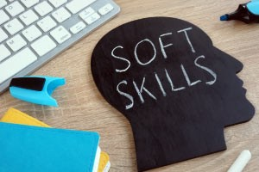

Interpersonal Skills - Advanced Soft Skills

This free online course, Interpersonal Skills - Advanced Soft Skills will help you to

upgrade your interpersonal skills set to achieve personal success in the workplace and

personal relationships. This course will begin with a discussion on the elements and

dimensions of emotional intelligence and various ways of improving your emotional

intelligence quotient (EQ).

Score

96

%

Study Time

4:31:43

Modules Studied

Module 1:

Emotional Intelligence and Brainstorming

Module 2:

Persuasion and Glossophobia

Module 3:

Course assessment